Title of paper

Author ¹, Corresponding Author ^{1,*}, Co-author ^{1,2}

¹ Affiliation 1
² Affiliation 2

* E-mail:

Keywords: non-conforming elastic contact; half-space assumption; FE method; characteristic size; significant dimensions.

- Introduction

This template contains guidelines to assist you when preparing your abstract for the submission to The Contact Mechanics and Wear of Rail/Wheel Systems Conference. The official language is English. The abstract must state clearly the purpose and relevant results of the research which should fit in with the conference topics. Broadly, topics of interest range from the fundamental studies in Rail/Wheel interfaces and material behaviour to the innovative solutions to practical railway engineering problems.

The abstract title should reflect the essential of the work. Please avoid including abbreviations. Authors' names and affiliations are to be written immediately after the title. For all the affiliations, a lower case superscript number should be placed after the authors' names and in front of the addresses. Also, ensure to provide the full postal address of each affiliation and a valid e-mail address of the corresponding author marked by a superscript star. Add keywords immediately after authors' affiliations. Five to seven keywords should be included.

- Writing abstract

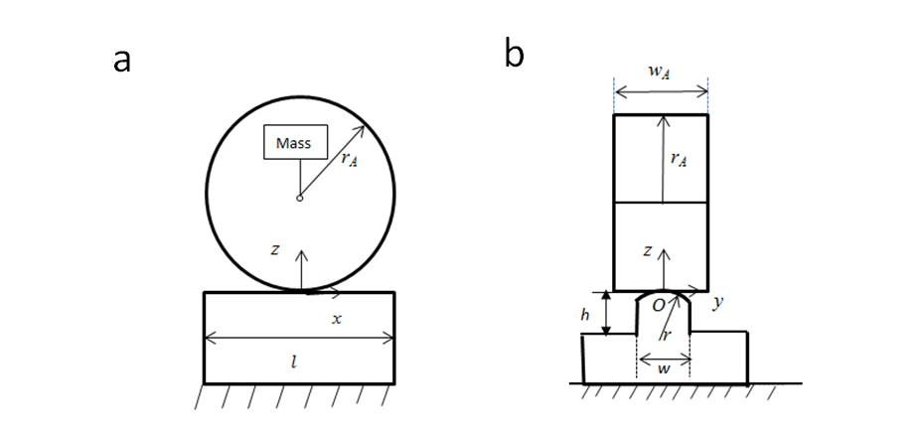
Fig. 1 Schematic diagrams of the FE model: (a) Front view; (b) Side view.
The preferred length of the abstract is approximately 1000 words (references do not count). The abstract will be subjected to a review process. The review committee may require amendments to your abstract. It is essential to submit your abstract in time. The important dates are presented in table 1:

Tab. 1 Important dates.
Event | Date
Abstract submission open | September 1, 2017
Deadline for abstract submission | December 1, 2017
Notification of abstract acceptance | March 1, 2018
Full paper submission | July 1, 2018

The following general guidelines should be adhered to:
- A4 page size,
- Single line spacing,
- Times New Roman font: regular, Size : 10 with justified alignment,
- No letterhead or company logos to be incorporated,
- Page numbers,
- Subsections should be numbered 1.1 (then 1.1.1, 1.1.2, ...), 1.2, etc. Each heading should appear on its own separate line,
- All figures and tables should be numbered and each one must be located as close as practical after the first reference to it,
- All micrographs must be clear,
- The quality of the figures should be above 300 dpi,
- All figures and tables titles should be in Times New Roman font italic, Size : 8 with centered alignment.

  - References

References are to be made by sequential index number [1], [2, 3], [1~3] with a listing in the Reference section at the end of the abstract. The formats below should be followed carefully (see examples below).
- Reference to journal articles:
Authors: title of article, Journal, year, volume (number) pages.
- Reference to conference articles should include editors, title of the proceedings and conference, and publisher:
Authors: title of article, Editors, Title of Proceedings, Publisher, City, Year, pages.
- Reference to books:
Authors: title of book, publisher, edition, year
- A private communication or company and agency reports may be cited when necessary. The citation must include the affiliation and, where necessary, the address of the person involved as well as the year. Papers presented at meetings but not published are in this category.

- Abstract submission

The submission system (https://easychair.org/conferences/?conf=cm2018) guides you through the process of entering your abstract details and uploading your files. An electronic copy of the abstract must be submitted in both DOC and PDF format.

- Conclusions

This document is the template for the abstract preparation. If you have any further queries please contact the CM2018 Secretariat: CM2018@tudelft.nl

References

- K.L. Johnson: Contact Mechanics, Cambridge University Press, 1985.
- J.J. Kalker: Survey of Wheel-Rail Rolling Contact Theory, Vehicle System Dynamics, 1979, 8(4) 317 – 358.
- P. Clayton P, M.B.P. Allery and P.J Bolton PJ: Surface damage phenomena in rails, in J. Kalousek R.V. Dukkipati and G.M.L. Gladwell (Ed), Proceedings of the conference on Contact Mechanics and Wear of Rail/wheel Systems, Vancouver, British Columbia, July 6-9, 1982, 419-443, University of Waterloo Press, 1983.

